Digital CMOS HW (18 points)
(jas, Digital CMOS HW.docx, 12/3/2025)

Clearly indicate answers and include units for numeric answers, using 3 or 4 significant figures. Show at least the major steps of your work so that if necessary partial credit can be awarded.
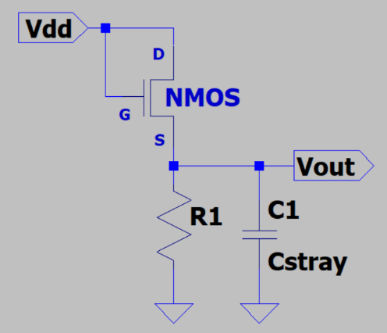
- The adjacent circuit shows an n-channel enhancement mode MOSFET configured as a pull-up transistor with R1 representing a very large resistance associated with digital CMOS. In your own words and using complete sentences, explain why an n-channel enhancement mode MOSFET is a poor digital pull-up transistor, referencing the adjacent circuit as necessary.
(3 Points.)

A n-channel MOSFET is a poor digital pull-up transistor because it can’t pass the full Vdd signal through to Vout. This is because it has a threshold voltage, $V_{T}$, so the max that Vout can be is $V_{dd}-V_{t}$. But PMOS can pull all the way up to Vdd, because it turns on when the source to gate voltage is greater than $V_{T}$

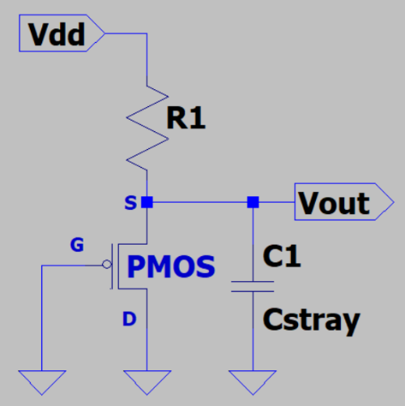
- The adjacent circuit shows a p-channel enhancement mode MOSFET configured as a pull-down transistor with R1 representing a very large resistance associated with digital CMOS. In your own words and using complete sentences, explain why a p-channel enhancement mode MOSFET is a poor digital pull-down transistor. (3 Points.)

A PMOS is a bad digital pull-down transistor because it can’t pull all the way down to 0V, this is because the source is tied to the Vdd, so the voltage across the source and gate always has to be at least $V_{T}$ in order to conduct.

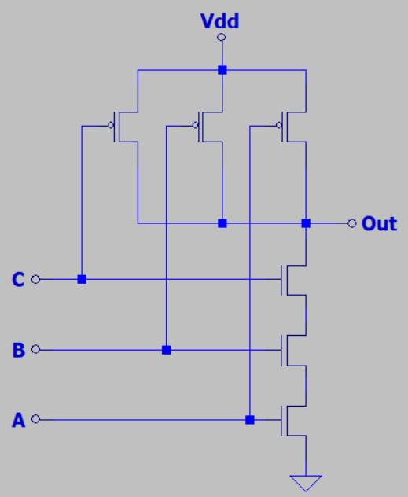
- Determine the widths of the n-channel enhancement mode MOSFETs in the adjacent digital logic circuit necessary to provide the same fall time as an inverter with the n-channel pull-down transistor sized at W/L. Then, given µ_{n}/µ_{p} = 2 for the CMOS process, size the p-channel enhancement mode MOSFETs to provide for equal rise and fall times. Your answer should include the relative width W, but not the relative length L.
(4 Points.)

$$3 NMOS in series→length is 3L$$
$$To make\frac{W}{L}, *each W by 3$$
$$W_{n_individual}=3W$$

nMOS Pull-Down Widths = 3W

$$W_{p}=\frac{μ_{n}}{μ_{p}}W_{n}=2\left(3W\right)=6W$$
pMOS Pull-Up Widths = 6W
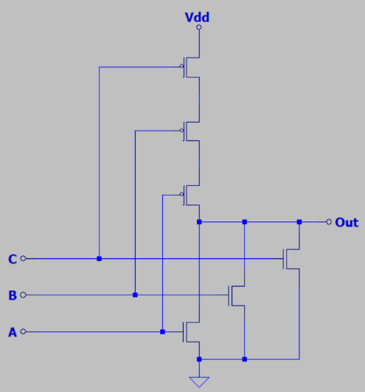
- Determine the widths of the n-channel enhancement mode MOSFETs in the adjacent digital logic circuit necessary to provide the same fall time as an inverter with the n-channel pull-down transistor sized at W/L. Then, given µ_{n}/µ_{p} = 2 for the CMOS process, size the p-channel enhancement mode MOSFETs to provide for equal rise and fall times. Your answer should include the relative width W, but not the relative length L. (4 Points.)

3 NMOS in // $→$ treat individually.
$$W_{n}=W$$
nMOS Pull-Down Widths = W

$$W_{p}=\frac{μ_{n}}{μ_{p}}W_{n}=2\left(W\right)=2W\left(total\right)$$
$$W_{p}\left(individual\right)=2W\left(\#\right)=2W\left(3\right)=6W$$
pMOS Pull-Up Widths = 6W

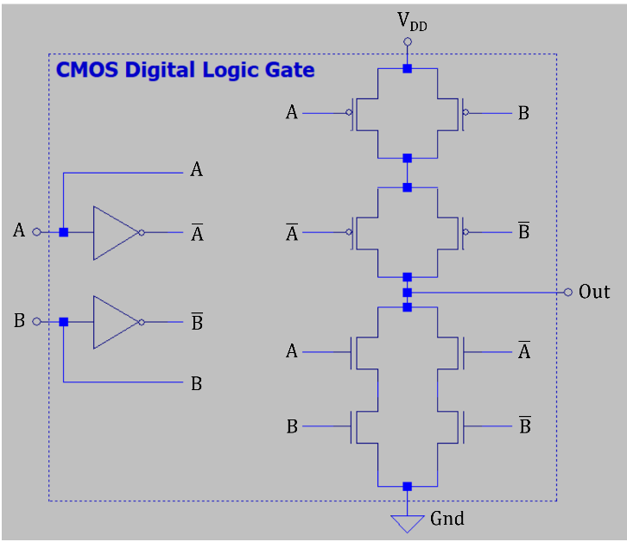
- Complete the Out column of the truth table below for the adjacent CMOS logic gate. (4 Points.)

B | A | Out
0 | 0 | 0
0 | 1 | 1
1 | 0 | 1
1 | 1 | 0

PUN conducts when either B or A is true, but not both. PDN conducts when neither B nor A is true. This means that out is the XNOR function
$$Out=A⊕B$$

